0.7训练集

选择的类别：['snoopy', 'bonsai', 'cougar_body', 'stegosaurus', 'flamingo_head']

image_table_5_all_k200.pkl

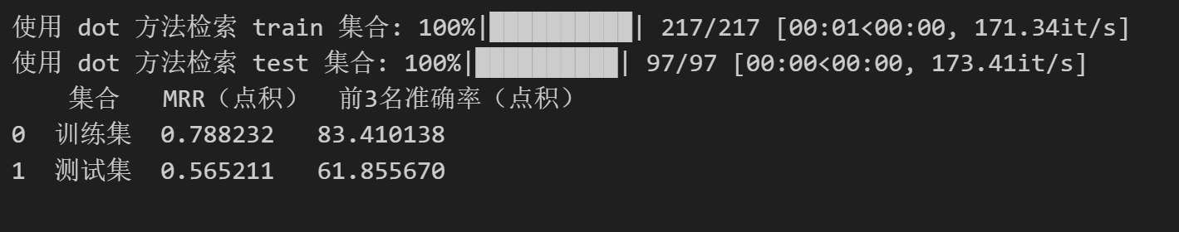

300

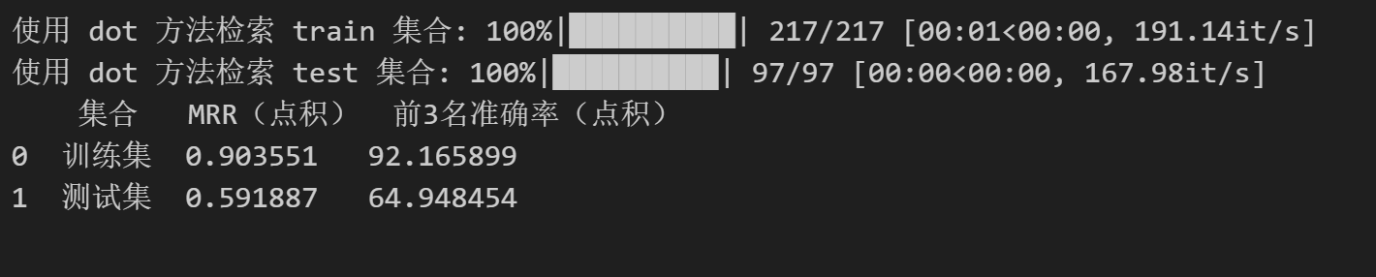

400

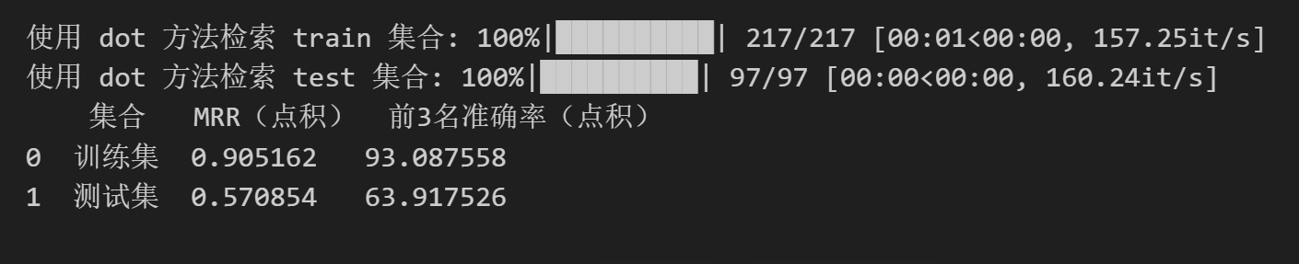

50%-50% 20

N = 20 （seed = 10）

['pizza', 'BACKGROUND_Google', 'ketch', 'mandolin', 'airplanes', 'crocodile_head', 'lobster', 'mayfly', 'euphonium', 'sea_horse', 'chandelier', 'Motorbikes', 'flamingo_head', 'bonsai', 'dragonfly', 'watch', 'hawksbill', 'barrel', 'kangaroo', 'ceiling_fan']

200

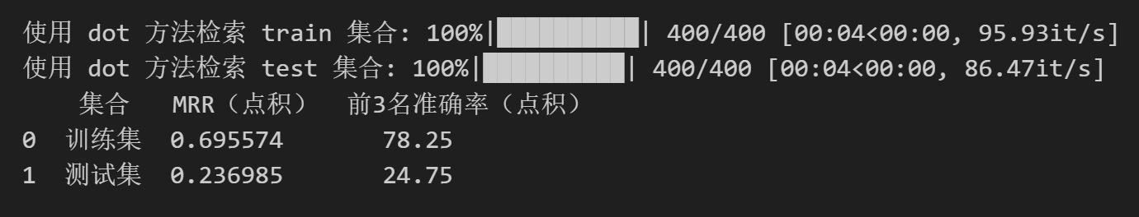

500

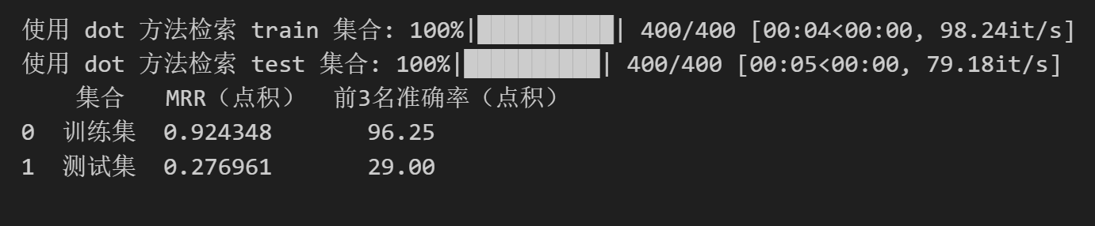

1000

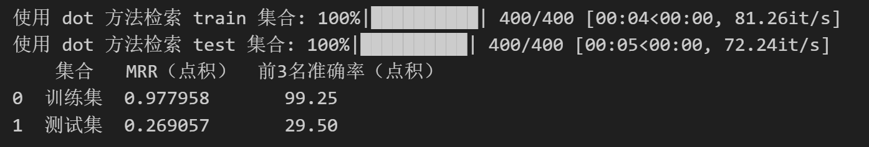

1500

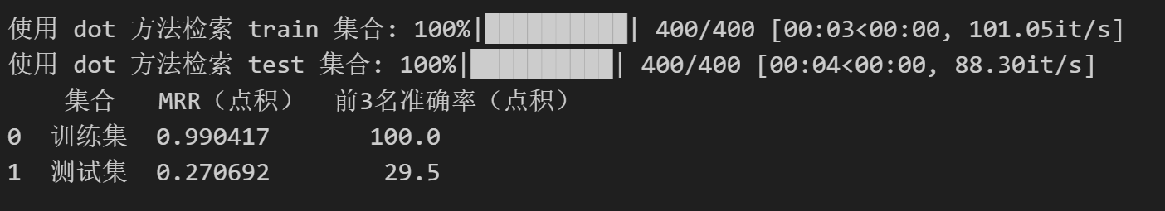

50%-50% 20(小于50均分)

N = 20 （seed = 10）

['pizza', 'BACKGROUND_Google', 'ketch', 'mandolin', 'airplanes', 'crocodile_head', 'lobster', 'mayfly', 'euphonium', 'sea_horse', 'chandelier', 'Motorbikes', 'flamingo_head', 'bonsai', 'dragonfly', 'watch', 'hawksbill', 'barrel', 'kangaroo', 'ceiling_fan']

K = 1000

K = 1500

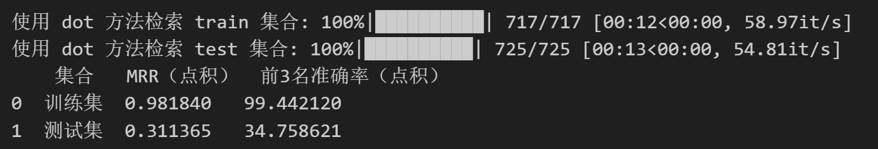

K = 2000

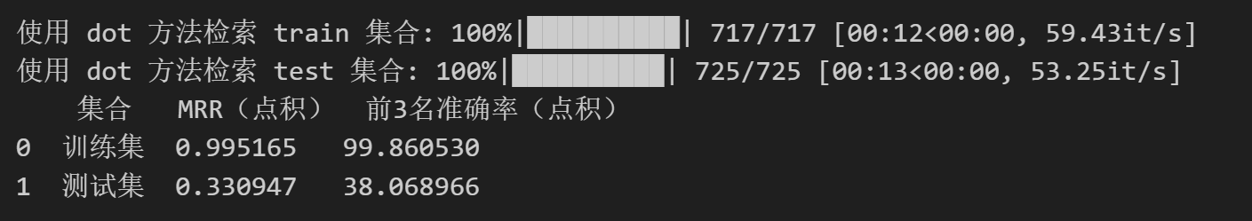

5(seed = 10)

N = 10

选择的类别：['pizza', 'BACKGROUND_Google', 'ketch', 'mandolin', 'airplanes']

K = 100

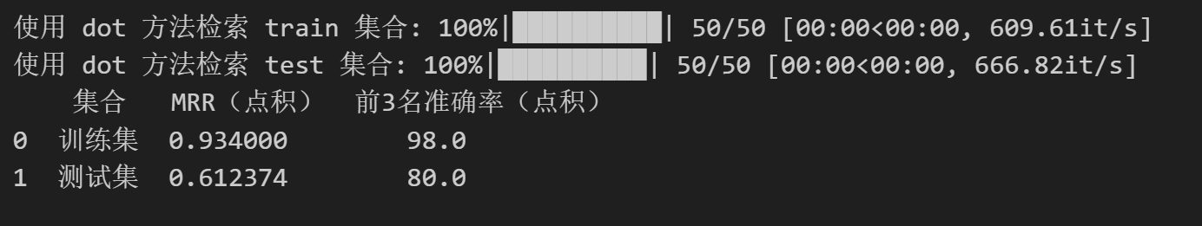

K = 200

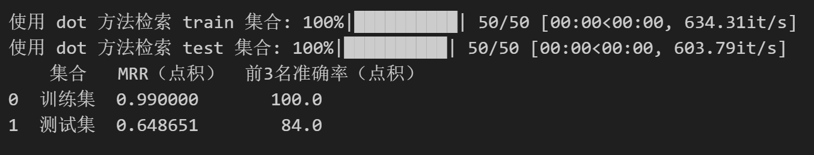

K = 300

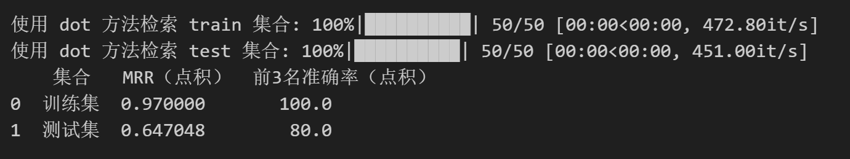

K = 400

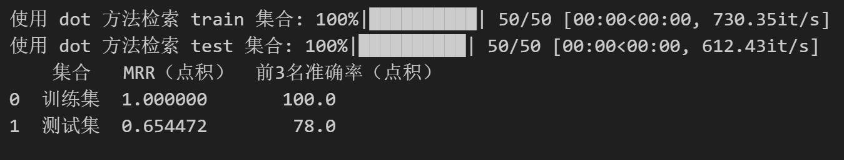

K = 500

